Final Report (Output)

**---------------------STATISTICS------------------**

max min mean median standard deviation

X 9 1 4.66925 4 2.31378

Y 9 2 4.29981 4 1.2299

FFMC 96.2 18.7 90.6447 91.6 5.52011

DMC 291.3 1.1 110.872 108.3 64.0465

DC 860.6 7.9 547.94 664.2 248.066

ISI 56.1 0 9.02166 8.4 4.55948

temp 33.3 2.2 18.8892 19.3 5.80663

RH 100 15 44.2882 42 16.3175

wind 9.4 0.4 4.0176 4 1.79165

rain 6.4 0 0.0216634 0 0.295959

area 1090.84 0 12.8473 0.52 63.6558

**------Correlation between area and other attributes------**

X 0.063385

Y 0.044873

FFMC 0.040122

DMC 0.072994

DC 0.049383

ISI 0.008258

temp 0.097844

RH -0.075519

wind 0.012317

rain -0.007366

Name: area, dtype: float64

--------------------------------------------------------

**The attribute which is most correlated to area is temp**

--------------------------------------------------------

**---------------------AREA VS X ---------------------**

Linear Model For Area vs X is [area = 1.60896357512 * X + 6.4114377691]

Root Mean Squared Error is 63.47624580804098

R-Squared Value is 0.00370696346691

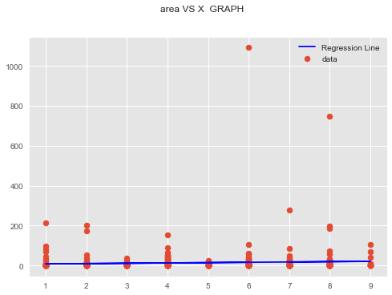

**-------------------------------------------------------**

**---------------------AREA VS Y ---------------------**

Linear Model For Area vs Y is [area = 2.1919948358 * Y + 4.07931272643]

Root Mean Squared Error is 63.533768115206954

R-Squared Value is 0.00190045962767

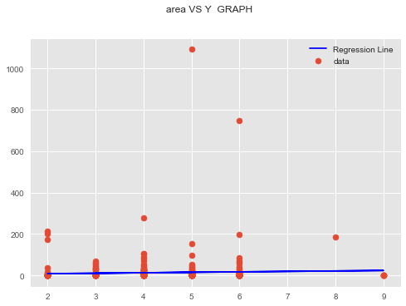

-------------------------------------------------------

**---------------------AREA VS month ---------------------**

Linear Model For Area vs month is [area = 1.513805072 * month + 2.25065656566 ]

Root Mean Squared Error is 63.49692028411164

R-Squared Value is 0.00305786424306

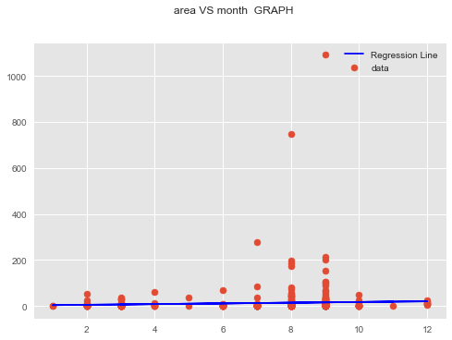

-------------------------------------------------------

**---------------------AREA VS FFMC ---------------------**

Linear Model For Area vs FFMC is [area = 0.462671689613 * FFMC + -29.0914355742 ]

Root Mean Squared Error is 63.54301916216229

R-Squared Value is 0.0016097752177

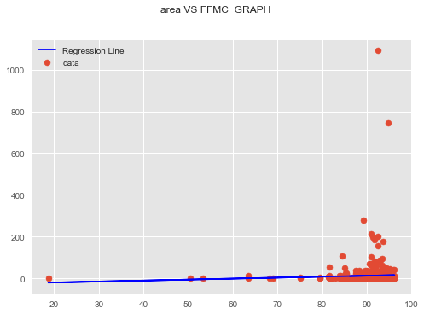

-------------------------------------------------------

**---------------------AREA VS DMC ---------------------**

Linear Model For Area vs DMC is [area = 0.072549053565 * DMC + 4.80360870522 ]

Root Mean Squared Error is 63.424579367412946

R-Squared Value is 0.00532816728518

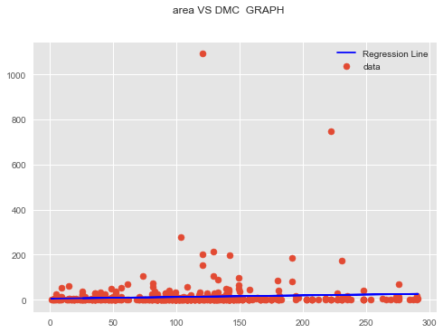

-------------------------------------------------------

**---------------------AREA VS DC ---------------------**

Linear Model For Area vs DC is [area = 0.0126721404613 * DC + 5.90371893507 ]

Root Mean Squared Error is 63.516634935598375

R-Squared Value is 0.00243870294092

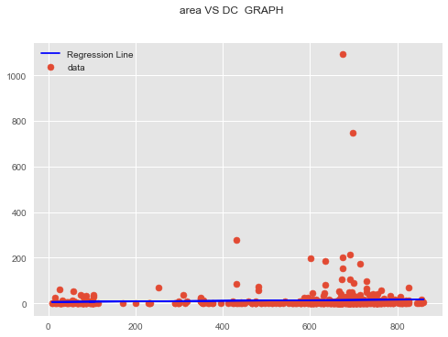

-------------------------------------------------------

**---------------------AREA VS ISI ---------------------**

Linear Model For Area vs ISI is [area = 0.115287314309 * ISI + 11.8072087207 ]

Root Mean Squared Error is 63.59205771952823

R-Squared Value is 6.81894084784e-05

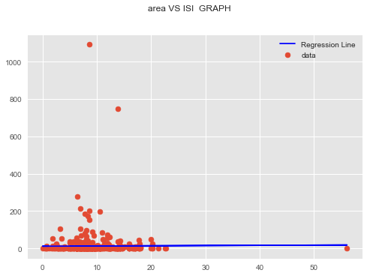

-------------------------------------------------------

**---------------------AREA VS temp ---------------------**

Linear Model For Area vs temp is [area = 1.07262762106 * temp + -7.41375156477 ]

Root Mean Squared Error is 63.2890852262009

R-Squared Value is 0.00957346934149

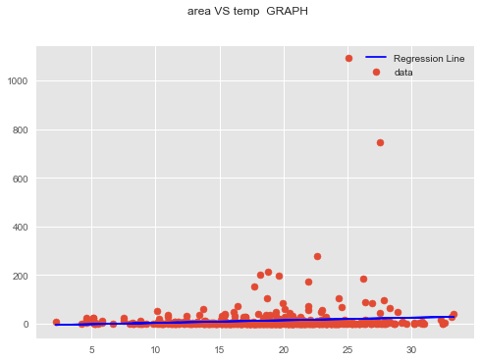

-------------------------------------------------------

**---------------------AREA VS RH ---------------------**

Linear Model For Area vs RH is [area = -0.294512209719 * RH + 25.8058292973 ]

Root Mean Squared Error is 63.412682883308634

R-Squared Value is 0.00570127146668

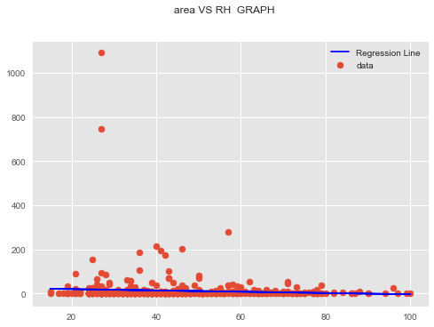

-------------------------------------------------------

**---------------------AREA VS wind ---------------------**

Linear Model For Area vs wind is [area = 0.437621858853 * wind + 11.0891018123 ]

Root Mean Squared Error is 63.58940169097858

R-Squared Value is 0.000151715309948

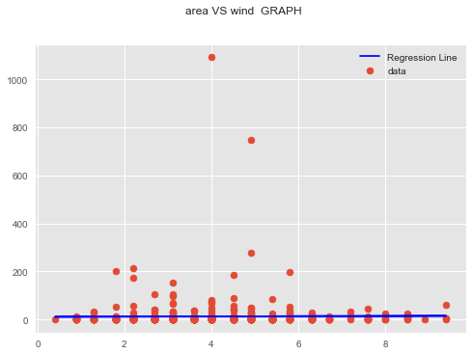

-------------------------------------------------------

**---------------------AREA VS rain ---------------------**

Linear Model For Area vs rain is [area = -1.5842442175 * rain + 12.8816122538 ]

Root Mean Squared Error is 63.59250083987431

R-Squared Value is 5.42539678081e-05

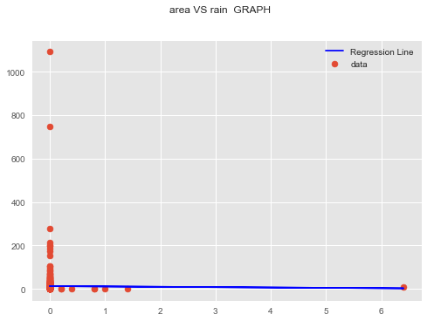

-------------------------------------------------------

**FINAL CONCLUSION :-**

More temp More Area Burnt

-------------------------------------------------------

**---------------Prediction on basis of simple linear regression-------------**

Value of temp for which area burnt is to be predicted is : 40

Predicted value of area burnt is 35.4913532776

---------------------------------------------------------------------------

**------------------------Multivariate linear regression---------------------**

OLS Regression Results

===========================================================================

Dep. Variable: area R-squared: 0.025

Model: OLS Adj. R-squared: 0.002

Method: Least Squares F-statistic: 1.092

Date: Wed, 16 May 2018 Prob (F-statistic): 0.364

Time: 01:16:14 Log-Likelihood: -2873.8

No. Observations: 517 AIC: 5774.

Df Residuals: 504 BIC: 5829.

Df Model: 12

Covariance Type: nonrobust

===========================================================================

coef std err t P>|t| [0.025 0.975]

---------------------------------------------------------------------------

Intercept -16.1538 63.420 -0.255 0.799 -140.755 108.447

X 1.9002 1.450 1.311 0.191 -0.948 4.748

Y 0.3241 2.754 0.118 0.906 -5.086 5.734

month 2.9004 2.791 1.039 0.299 -2.583 8.384

day 1.3269 1.320 1.005 0.315 -1.267 3.921

FFMC -0.1127 0.663 -0.170 0.865 -1.415 1.190

DMC 0.0966 0.071 1.369 0.172 -0.042 0.235

DC -0.0315 0.032 -0.981 0.327 -0.095 0.032

ISI -0.7305 0.772 -0.947 0.344 -2.247 0.786

temp 0.9546 0.797 1.198 0.232 -0.612 2.521

RH -0.1758 0.241 -0.730 0.466 -0.649 0.297

wind 1.2321 1.702 0.724 0.470 -2.113 4.577

rain -3.1958 9.683 -0.330 0.742 -22.220 15.829

===========================================================================

Omnibus: 972.663 Durbin-Watson: 1.643

Prob(Omnibus): 0.000 Jarque-Bera (JB): 769640.593

Skew: 12.508 Prob(JB): 0.00

Kurtosis: 190.356 Cond. No. 1.41e+04

**---------------Multivariate Linear Regression Model For Area--------------**

1.9002*X + 0.3241*Y + 2.9004*month + 1.3269*day - 0.1127*FFMC + 0.0966*DMC - 0.0315*DC - 0.7305*ISI + 0.9546*temperature - 0.1758*RH + 1.2321*wind - 3.1958*rain - 16.1538

--------------------------------------------------------------------------

**------------Prediction on basis of Multivariate linear regression----------**

Value of attributes for which area burnt is to be predicted is :

X = 6, Y = 3, month = 11, day = 3, FFMC = 79.5, DMC = 3, DC = 106.7, ISI = 1.1, temperature = 11.8, RH = 31, wind = 4.5, rain = 0

Predicted value of area burnt is 2.969769999999997

---------------------------------------------------------------------------